# Instructions for uploading a file to a new git repository.

1. Log into git

The repository I crated for GDX is located here: <https://github.com/cestarne/gdx>. You should see it in the Top Repository section of your github home page.

1. Click *cstarne/gdx*

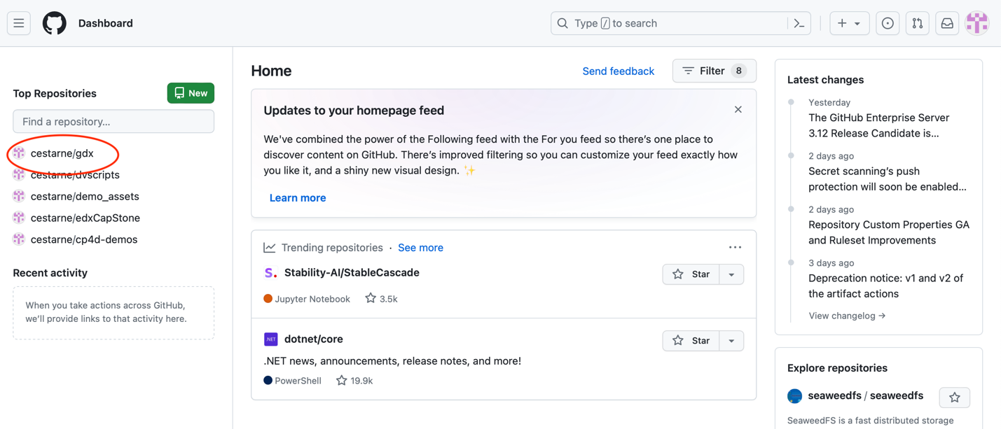

1. On the Code page click the down arrow on the Add file drop box.
2. Click on *uploading an files*.

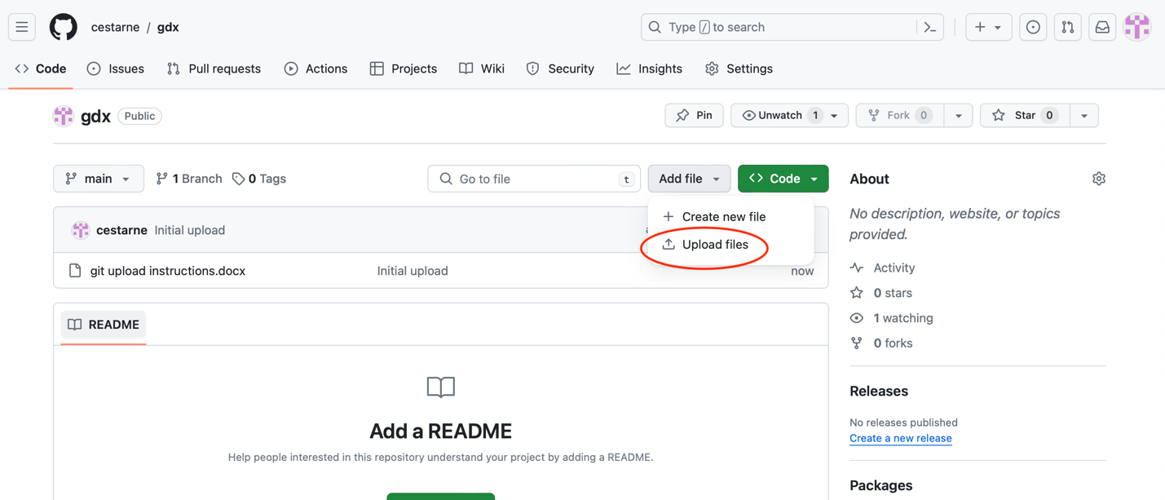

1. You should see the add files to a repository page.
2. Click *choose your files* and select the files you want to upload*.*
3. Add commit tag. I used *Initial upload* in the example below.
4. Press the Commit changes button.

1. You should see your uploaded files in the files list on the code tab.